1. **Navbar**

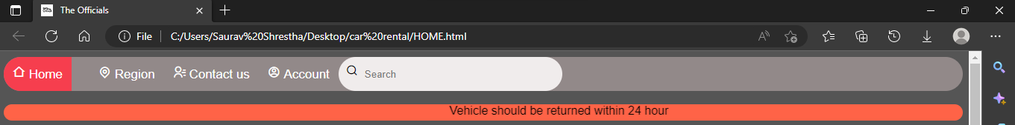Div, a, i, tags are used in the navigation bar. There are five tabs in the navigation bar: Home, Region, Contact Us, Account, and a Search bar Regarding CSS display width, background-color, boarder-radius, padding are used. The :hover selector in css file is used to select elements when you mouse over them. . Link relation in head tag is a relation between two files which allows you to link your HTML document with another document or file. We also added favicon to the page using link element. We also created second nav bar using marquee element which is used to insert a scrolling area of text.

HTML Code used

<!DOCTYPE html>

<html lang="en">

<head>

  <meta charset="UTF-8">

  <title>The Officials </title>

   <link rel="stylesheet" href="HOME.css">

   <link href="https://cdn.jsdelivr.net/npm/remixicon@2.5.0/fonts/remixicon.css" rel="stylesheet">

   <link rel="icon" type="image/x-icon" href="FAVICON.png">

</head>

<body>

  <div class="navbar">

    <a class="active" href="#">

       <i class="ri-home-2-line"></i>

      Home

    </a>

    <a href="#">

      <div class="dropdown">

          <i class="ri-map-pin-line"></i>

          Region

        <div class="dropdown-content">

          <a href="#">Pradesh 1</a>

          <a href="#">Pradesh 2</a>

          <a href="#">Pradesh 3</a>

          <a href="#">Pradesh 4</a>

          <a href="#">Pradesh 5</a>

          <a href="#">Pradesh 6</a>

          <a href="#">Pradesh 7</a>

        </div>

      </div>

    </a>

       <a href="#bottom">

        <i class="ri-contacts-line"></i>

         Contact us

        </a>

      <a href="login.html" target="_blank">

        <i class="ri-account-circle-line"></i>

       Account

      </a>

      <div class="search">

        <i class="ri-search-line"></i>

        <input type="text" placeholder="Search">

      </div>

  </div>

  <br>

  <div class="navbar1"><marquee behavior="" direction="Left">Vehicle should be returned within 24 hour</marquee></div>

CSS Code

*{

    margin: 10;

    padding: 10;

    box-sizing: border-box;

    font-family: "Poppins", sans-serif;

  }

/* nav bar */

.navbar {

  width: 100%;

  background-color: rgb(146, 137, 137);

  overflow: auto;

  border-radius: 100px;

}

.navbar1{

  width: 100%;

  background-color: tomato;

  overflow: auto;

  border-radius: 100px;

}

.navbar a {

  float: left;

  padding: 12px;

  color: white;

  text-decoration: none;

  font-size: 17px;

}

.navbar a:hover {

  opacity: 0.5;;

}

.active {

  background-color: #f63e4e;

}

/* nav */

.search{

  display: flex;

  align-items: right;

  background:rgb(240, 236, 236);

  width: 300px;

  height:2.9rem;

  padding:10px;

  border-radius:100px;

}

.search input{

  border:none;

  outline:none;

  background: transparent;

  margin-left: 7px;

}

.search o{

  font-size: 20px;

}

**b)Home section**

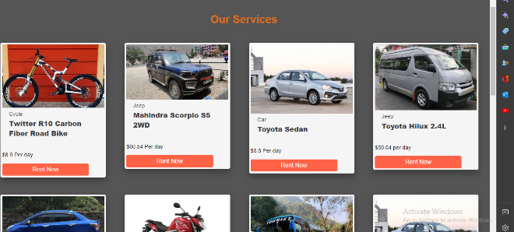We have used div, a, h1, p, and button tags for the home section. The image, description about vehicle, and Rent now button are all located in the home area. We have created multiple div with class to distinguish between image, description, price which makes us easy to select particular part in css. For CSS display attributes, such as justify-content, z-index, cursor, position, height, and width.

HTML Code

<h1 class="pheading">Our Services</h1>

  <div class="grid">

    <div class="products">

        <div class="card">

          <div class="img"><img src="cycle.png"alt=""></div>

          <div class="desc">Cycle</div>

          <div class="title">Twitter R10 Carbon Fiber Road Bike </div>

          <div class="box"></div>

          <div class="price">$8.5 Per day</div>

          <a href="rentnow.html" target="_blank">

          <button class="btn">Rent Now</button>

 </a>

          </div>

          </div>

          <div class="products">

            <div class="card">

              <div class="img"><img src="scorpio.png"alt=""></div>

              <div class="desc">Jeep</div>

              <div class="title">Mahindra Scorpio S5 2WD</div>

              <div class="box"></div>

              <div class="price">$80.54 Per day</div>

              <a href="rentnow.html" target="_blank">

                <button class="btn">Rent Now</button>

               </a>                      </div>

              </div>

              <div class="products">

                <div class="card">

                  <div class="img"><img src="10.png"alt=""></div>

                  <div class="desc">Car</div>

                  <div class="title">Toyota Sedan</div>

                  <div class="box"></div>

                  <div class="price">$5.5 Per day</div>

                  <a href="rentnow.html" target="_blank">

                    <button class="btn">Rent Now</button>

                   </a>                          </div>

                  </div>

CSS Code

body{

    background-repeat: no-repeat;

    background-size: 1450px;

    background-color: #555

  }

  p{

    margin-bottom: 1.7rem;

  }

  button{

    font-size: 1.1rem;

    margin-top: 1rem;

    padding: 8px 0;

    border-radius: 5px;

    outline: none;

    border: none;

    width: 85%;

    background: tomato;

    color:white;

    cursor: pointer;

  }

  button:hover{

    opacity: 0.8;

  }

  .pheading{

      text-align: center;

      margin: 50px 0;

      color:rgb(218, 112, 25);

  }

  .products .card{

      width: 310px;

      background: #f5f5f5;

      box-shadow: 0 10px 20px rgba(0, 0, 0, 0.3);

      border-radius: 5px;

      padding: 5px;

      margin-bottom: 20px;

  }

  .products .card img{

    height: 250 px;

    width: 100%;

  }

  .products .card .desc{

    padding: 5px 20px;

    opacity: 0.8;

  }

  .products .card .title{

    font-weight: 900;

    font-size: 20px;

    color: #424144;

    padding: 0 20px;

  }

  .products .card .box{

    display: flex;

    justify-content: space-between;

    align-items: center;

    padding: 20px;

  }

  .products .card .box .price{

    color: red;

    font-size: 20px;

    font-weight: bold;

  }

  .products .card .box .btn{

    font-size: 13px;

    color: #f63e4e;

    padding: 10px 18px;

    font-weight: 900;

    border: 1px solid #f63e4e;

    border-radius: 20px;

  }

  .products .card .box .btn:hover{

    cursor: pointer;

    background-color: #f63e4e;

    color: #424144;

  }

  .grid{

    display: grid;

    grid-template-columns: 1fr 1fr 1fr 1fr ;

    grid-row-gap: 30px;

    grid-column-gap: 30px;

  }

  .dropdown {

    float: left;

    overflow: hidden;

  }

  .dropdown .dropbtn {

    font-size: 16px;

    border: none;

    outline: none;

    color: #424144;

    padding: 14px 16px;

    background-color: inherit;

    font-family: inherit;

    margin: 0;

  }

  .navbar a:hover, .dropdown:hover .dropbtn {

    background-color: red;

  }

  .dropdown-content {

    display: none;

    position: absolute;

    background-color:#424144;

    min-width: 160px;

    box-shadow: 0px 8px 16px 0px rgba(0,0,0,0.2);

    z-index: 1;

  }

  .dropdown-content a {

    float: none;

    color: black;

    padding: 12px 16px;

    text-decoration: none;

    display: block;

    text-align: left;

  }

  .dropdown-content a:hover {

    background-color: #ddd;

  }

  .dropdown:hover .dropdown-content {

    display: block;

  }

**c)Footer**

Div, footer, br, a, span, p, h2 tags are the elements we employ for the footer. Detailed contact information for our various branchs are provided in the footer section. In relation to CSS display attributes, such as color, padding, text-align, border-radius and background-color are used.

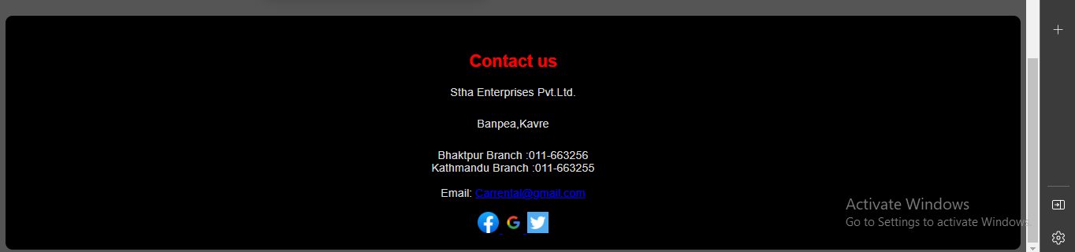

HTML Code

<footer>

  <h2>Contact us</h2>

  <p>Stha Enterprises Pvt.Ltd.</p>

  <p>Banpea,Kavre</p>

      <span>Bhaktpur Branch</span>

      :011-663256

    <br>

      <span>Kathmandu Branch</span>

      :011-663255

    <br>

    <br>

 Email: <a href="#">Carrental@gmail.com</a>

     <br>

     <br>

     <div>

      <a href="#">

      <img src="facebook.jpeg" style="width: 30px;" alt="">

      <img src="google.jpeg" style="width: 30px;" alt="">

      <img src="twitter.jpeg.png" style="width: 30px;" alt="">

    </a>

    </div>

</div>

</footer>

</body>

</html>

CSS Code

 footer{

    background-color: black;

    color: #ddd;

    text-align: center;

    padding: 30px 0 20px 0;

    border-radius: 10px;

  }

 h2{

  color: red;

}

e)Login

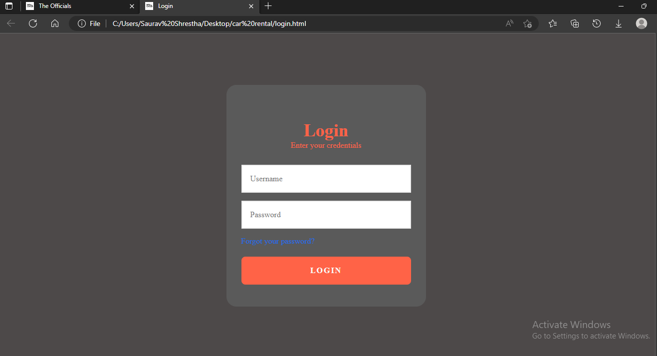Div, form, a, button, h and input tags are used in the login sections. Users and administrators can sign in to the website for renting using the login sections. For CSS display attributes we have used text-decoration, transition, and font-size, padding, height, margin, width and many more elements.

HTML Code

<!DOCTYPE html>

<html lang="en">

  <head>

    <title>Login</title>

    <link rel="stylesheet" href="css.css" />

    <link rel="icon" type="image/x-icon" href="FAVICON.png">

  </head>

  <body>

    <div class="login-card">

      <h2>Login</h2>

      <h3>Enter your credentials</h3>

      <form class="login-form">

        <input type="text" placeholder="Username" />

        <input type="password" placeholder="Password" />

        <a href="">Forgot your password?</a>

        <button type="submit">LOGIN</button>

      </form>

    </div>

  </body>

</html>

CSS Code

* {

  box-sizing: border-box;

}

html,

body,

.wrapper {

  height: 100%;

}

@keyframes rotate {

  100% {

    background-position: 15% 50%;

  }

}

body {

  display: grid;

  place-items: center;

  margin: 0;

  padding: 0 24px;

  background-color: rgb(77, 73, 73);

  color: whitesmoke;

}

.login-card {

  position: relative;

  z-index: 3;

  width: 100%;

  margin: 0 20px;

  padding: 70px 30px 44px;

  border-radius: 1.25rem;

  background: rgb(90, 90, 90);

  text-align: center;

}

@media (width >= 500px) {

  .login-card {

    margin: 0;

    width: 400px;

  }

}

.login-card > h2 {

  font-size: 36px;

  font-weight: 600;

  margin: 0 0 ;

  color: tomato;

}

.login-card > h3 {

  color: tomato;

  margin: 0 0 30px;

  font-weight: 500;

  font-size: 1rem;

}

.login-form {

  width: 100%;

  margin: 0;

  display: grid;

  gap: 16px;

}

.login-form > input,

.login-form > button {

  width: 100%;

  height: 56px;

}

.login-form > input {

  border: 2px solid #ebebeb;

  font-family: inherit;

  font-size: 16px;

  padding: 0 16px;

}

.login-form > button {

  cursor: pointer;

  width: 100%;

  height: 56px;

  padding: 0 16px;

  border-radius: 0.5rem;

  background: tomato;

  color: #f9f9f9;

  border: 0;

  font-family: inherit;

  font-size: 1rem;

  font-weight: 600;

  text-align: center;

  letter-spacing: 2px;

}

.login-form > a {

  color: #216ce7;

  font-size: 1rem;

  text-align: left;

  text-decoration: none;

  margin-bottom: 6px;

}

f) Rent Now

Div, button, form,h and input tags are used in the renting page. Users have to input their user indentification and click on submit form for renting a vehicle. . For CSS display attributes we have used text-decoration, transition, and font-size, padding, height, margin, width and many more elements.

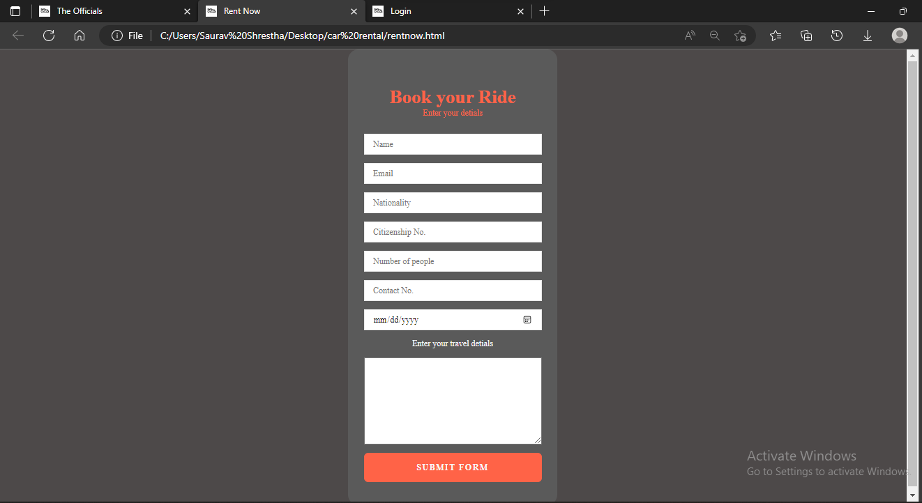

HTML Code

<!DOCTYPE html>

<html lang="en">

  <head>

    <title>Rent Now</title>

    <link rel="stylesheet" href="rentnow.css">

    <link rel="icon" type="image/x-icon" href="FAVICON.png">

  </head>

  <body>

    <div class="login-card">

      <h2>Book your Ride</h2>

      <h3>Enter your detials</h3>

      <form class="login-form">

        <input type="text" placeholder="Name" />

        <input type="email" placeholder="Email" />

        <input type="text" placeholder="Nationality">

        <input type="text" placeholder="Citizenship No.">

        <input type="number" placeholder="Number of people">

        <input type="text" placeholder="Contact No.">

        <input type="date" placeholder="journey start">

        Enter your travel detials

        <textarea name="" id="" cols="30" rows="10"></textarea>

        <button type="submit">SUBMIT FORM</button>

      </form>

    </div>

  </body>

</html>

CSS Code

* {

    box-sizing: border-box;

  }

  html,

  body,

  .wrapper {

    height: 100%;

  }

  @keyframes rotate {

    100% {

      background-position: 15% 50%;

    }

  }

  body {

    display: grid;

    place-items: center;

    margin: 0;

    padding: 0 24px;

    background-color: rgb(77, 73, 73);

    color: whitesmoke;

  }

  .login-card {

    position: relative;

    z-index: 3;

    width: 100%;

    margin: 0 20px;

    padding: 70px 30px 44px;

    border-radius: 1.25rem;

    background: rgb(90, 90, 90);

    text-align: center;

  }

  @media (width >= 500px) {

    .login-card {

      margin: 0;

      width: 400px;

    }

  }

  .login-card > h2 {

    font-size: 36px;

    font-weight: 600;

    margin: 0 0 ;

    color: tomato;

  }

  .login-card > h3 {

    color: tomato;

    margin: 0 0 30px;

    font-weight: 500;

    font-size: 1rem;

  }

  .login-form {

    width: 100%;

    margin: 0;

    display: grid;

    gap: 16px;

  }

  .login-form > input,

  .login-form > button {

    width: 100%;

    height: 40px;

  }

  .login-form > input {

    border: 2px solid #ebebeb;

    font-family: inherit;

    font-size: 16px;

    padding: 0 16px;

  }

  .login-form > button {

    cursor: pointer;

    width: 100%;

    height: 56px;

    padding: 0 16px;

    border-radius: 0.5rem;

    background: tomato;

    color: #f9f9f9;

    border: 0;

    font-family: inherit;

    font-size: 1rem;

    font-weight: 600;

    text-align: center;

    letter-spacing: 2px;

  }

  .login-form > a {

    color: #216ce7;

    font-size: 1rem;

    text-align: left;

    text-decoration: none;

    margin-bottom: 6px;

  }